   
**http://redcap.providence.org/redcap**

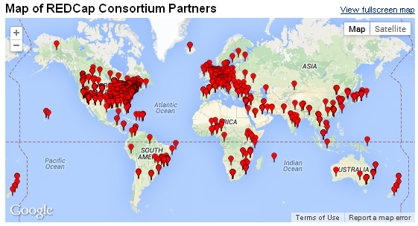What is REDCap?    
REDCap is a secure web-based application that supports data capture and management for research studies and quality improvement projects. REDCap is designed to quickly and intuitively build and manage online surveys and databases. 

Who uses it?  
The **REDCap Consortium** is composed of **1,040 active institutional partners** from CTSA, GCRC, RCMI and other institutions in **80 countries**. It is currently in production use or development build-status for more than **113,000 projects** with over **146,000 users.**  
Currently within Providence, there are 130 total projects and 215 active users.  
  
Key Features

* **Fast** - Intuitive user interface streamlines the design process.
* **Easy to Use** - No database experience is needed to begin using the software. Built-in online support/training videos.
* **Flexible** - Users can independently make project modifications, even after data   
  collection has begun.
* **Autonomous utilization** - project owners have autonomy and control to add new users
* **Secure** (Providence ID/password, Providence internal network access only, HIPAA/HITECH compliant)
* **Audit trail** (who did what when)
* **Multiple Users**/ multiple sites with access to different roles, forms & functions
* **Data Validation** - restrict fields to picklists, number ranges, dates, etc.
* **Data Export** - Automated export procedures for seamless data downloads to common   
  statistical packages (R, SPSS, etc.) and Excel.

**http://redcap.providence.org/redcap**

Data Entry

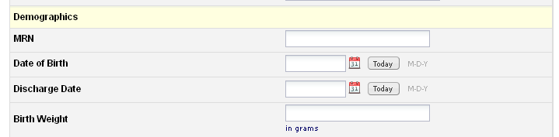The data entry forms are intuitive and require minimal training for end users.

**Features:** branching logic, field validation, field editing history, query resolution

**Field types:** Text, numeric, dates, Yes/No, long paragraphs, pick lists, check boxes, radio buttons, Visual Analog Scale slider.

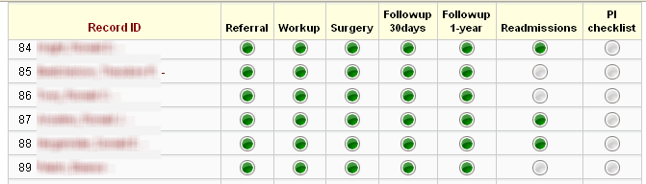Record Status Dashboard

This dashboard displays the completion status, which is especially helpful for longitudinal projects and projects with multiple forms.

### Audit Log

This dashboard displays the completion status, which is especially helpful for longitudinal projects and projects with multiple forms.

### Protected Information

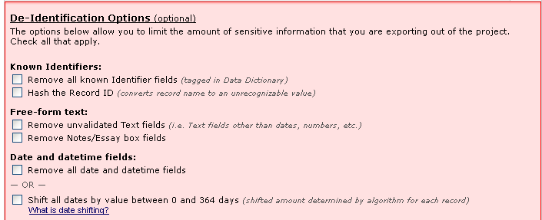Patient identifiers (name, DOB, MRN, etc.) can be removed from the data exports, which is required when working with outside statisticians/team members, etc.

### User access

The project owner has the ability to add/remove users and control what functions they can access

### Data Quality

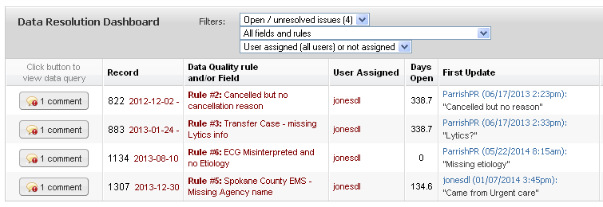Users can begin a documented process of resolving an issue with the data. The conversation and final resolution are logged for each data element.

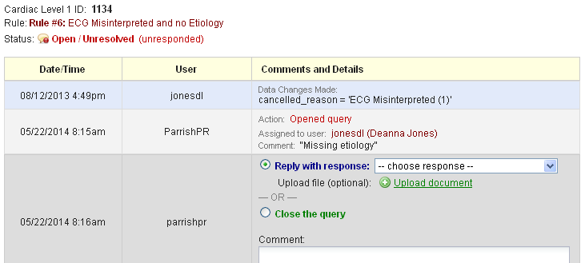

## Getting Started

1. Go to <http://redcap.providence.org/redcap>
2. Use your Providence ID/password. The first access will require a confirmation by email.
3. View the Training Resources

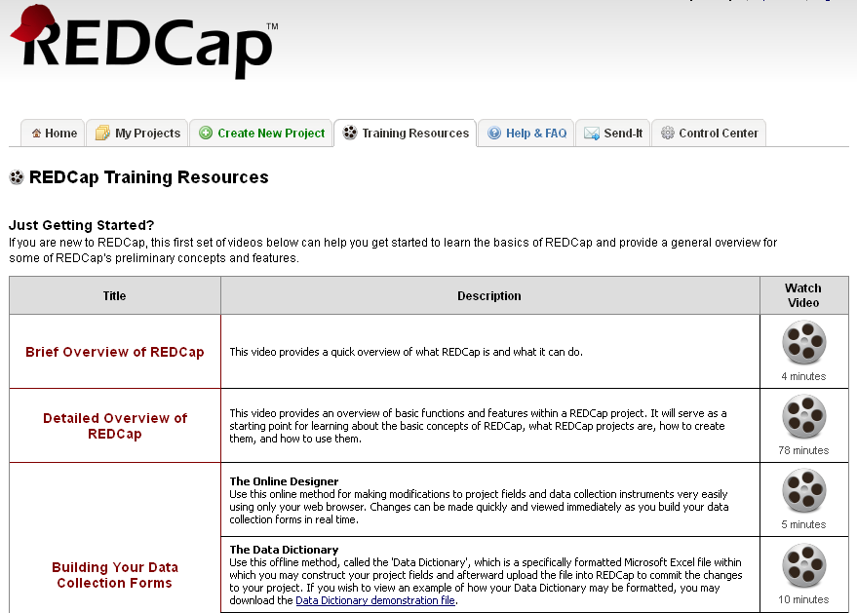

1. Click ‘Create a new Project’

